Threats and Countermeasures – Lecture 12 Everything Else
Collection
- “Collection consists of techniques adversaries may use to gather information and the sources information is collected from that are relevant to following through on the adversary’s objectives. Frequently, the next goal after collecting data is to either steal (exfiltrate) the data or to use the data to gain more information about the target environment. Common target sources include various drive types, browsers, audio, video, and email. Common collection methods include capturing screenshots and keyboard input.” – MITRE
Command and Control
- “Command and Control consists of techniques that adversaries may use to communicate with systems under their control within a victim network. Adversaries commonly attempt to mimic normal, expected traffic to avoid detection. There are many ways an adversary can establish command and control with various levels of stealth depending on the victim’s network structure and defenses.” – MITRE
Motivations
- Why do people or organizations attack systems?
  - Money
  - Information
  - Resources
  - Other effects
Botnets
- DDOS
- Phishing
- Ad fraud
- Crypto Mining
- Attack vector obfuscation
Advanced Persistent Threats
- 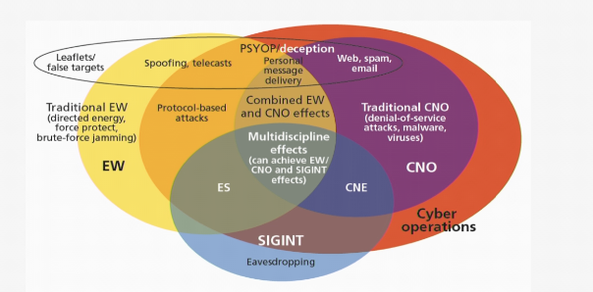
Secondary Motivation
- Stealth
  - Primary focus on avoiding detection
  - Willing to deploy more sophisticated capabilities
  - Focus on long term access – Persistence
- Attribution Avoidance
  - Primary focus on staying anonymous
  - Avoid unique capabilities
  - May be fine with short term effects
Command and Control
- Control of system
- Persistence management
- Data Exfiltration
- Botnet Coordination
- Architectures
  - Centralized
  - Peer-to-Peer
  - Third Party
Egress
- Stealth Mechanisms
  - Beaconing
    - Sleep timer
    - Jitter
  - Domain Generation Algorithms
  - DNS Tunneling
  - Protocol Mimicry
Exfiltration
- Stealth Mechanisms
  - Encoding
  - Obfuscation
  - Steganography
Ingress
- Tool expansion
- Adaptable capability download
- Maintain minimal toehold
Zeus (Zbot)
- Discovered in 2007
- Source code released in 2011
- Spead through a variety of attack vectors
- Man-in-the-Middle Keylogger to steal banking, etc.
- Could lay dormant waiting for commands
- Distributed Command and Control, commands can come from anywhere
- Variants:
  - Ice-IX – first Zeus botnet
  - Shylock – steals banking
  - GameOver Zeus – Rasomware
Koobface Worm
- Discovered in 2008
- Most prolific worm in 2009
- Targeted email, social networking
- Posted enticing links on Facebook
- Resurfaced in 2013
- Bogus anti-virus protection, flash plugins
- Collects personal information – logons, banking
- Posts as you
- Connects to distributed C+C throughout the world
- Continually available to download new capability

